CSE 113 Homework 1

Report

Loop Unrolling Independent Iterations for ILP
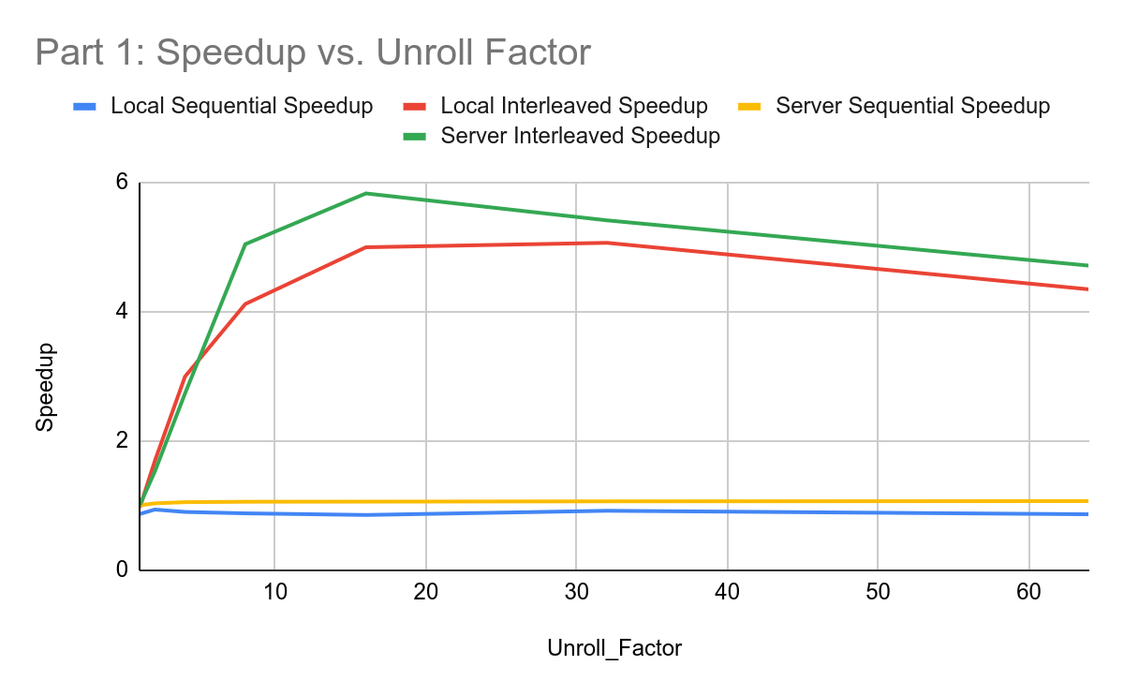
Image 1: Speedup vs. Unroll Factor

Part 1 tests how sequential Instruction-Level Parallelism (ILP) relates between an interleaved and sequential loop dealing with incrementing variables and storing them. The sequential loop will, depending on the chain_length, add up a specific tmp variable and then store that value to the respective array location depending on the unroll_factor times. The interleaving will instead interleave the additions together and then store the values from the tmp value to the proper location in the array.

What this demonstrates is that a level of parallelism caused the addition operations together to perform ~5x faster speedup. This is due to the bottle necking problem that occurs with the sequential loop in that it waits till the entire tmp variable is finished adding up, and then stores. However, ILP takes advantage of the computer architecture, specifically that data path execution pipeline in that it’s able to add multiple different variables without waiting for the variable to be stored, allowing for a much faster execution.

The results are roughly as I hypothesized, since I did take CSE 120 and in class, knew about how parallelism works at a lower level. However, I was shocked at how much of a difference it was. I didn’t expect ~5x faster execution times and was happy to see such a drastic change proving my interleaving execution was correct. It was also great to see how what we were learning in class was practically applicable in making more optimized programs.

Unrolling Reduction Loops for ILP

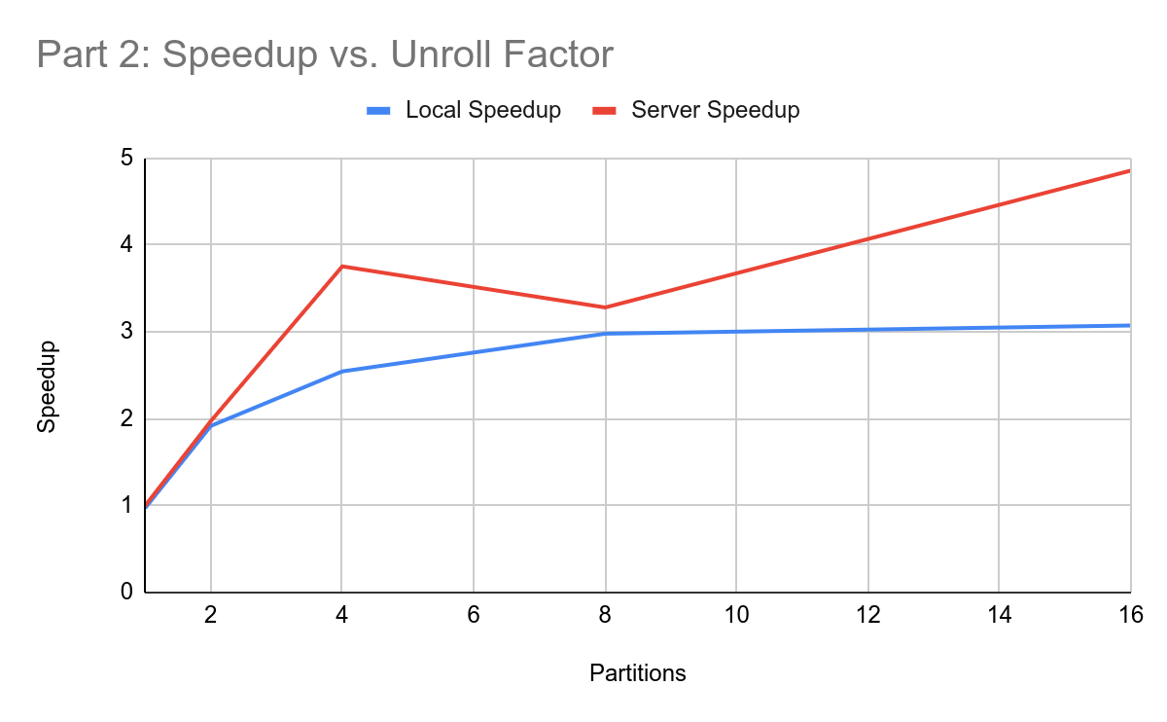
Image 2: Speedup vs. Partitions

Unrolling Reduction Loops with ILP showcases how relative to the reference unrolled value, a substantial improvement occurs from just including that ILP properties to the function. I just used what I did in Part 1 to answer the questions, creating a for loop for each “partition”. I noticed how partitions were similar to the unrolled_factor. Therefore, I just needed to implement that loop in python to create multiple sums and then use interleaving storage properties to add to the specific temporary “partition” variables the proper values as seen in the array, and then finally join and sum them all at the end.

My approach to this was coming in the mindset of writing in C++ while utilizing python loop capabilities and just adding onto the function body to then repeatedly instantiate temporary variables for each partition, create a for loop that skips by the number of partitions, and then add values to each partition depending on the for loop to the size of the array, and then summing it all together to a[0], the first index of the array.

I had the same expectations from the first part but it was nice to have more practice. However, I was kind of annoyed at the fact that the server seemed to have some jitter to it, as seen in the graph of my solution. For some reason, my local testing was ~3x speedup, however, the server’s side had a massive speedup of 4.85x. I had to resubmit this part because I believe the threshold was around 5x and just had to hope the server would for some reason have enough throttle to reduce my speedup. My local tests differ massively from the server and unfortunately, made it harder to know if it was a problem on my end or not.

SPMD Parallel Programming Using C++ Threads
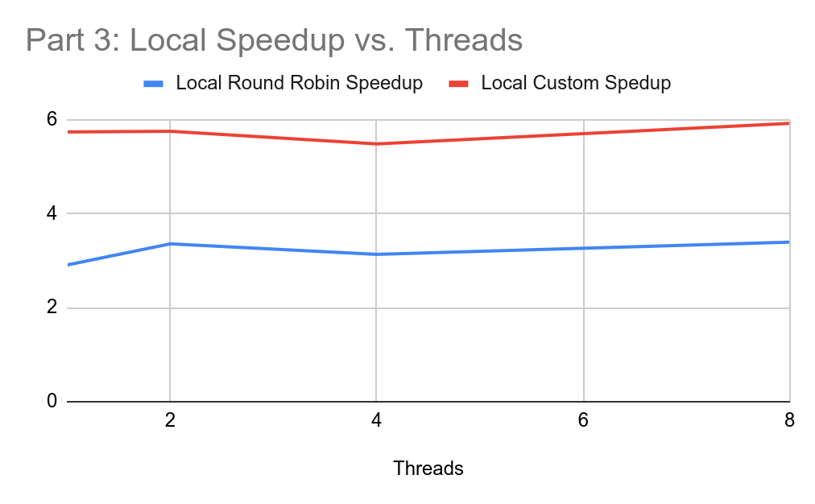
Image 3: Local Speedup vs. Threads

Three distinct algorithms were implemented using a Single Program Multiple Data (SPMD) programming model to explore the performance implications of thread-level parallelism. A sequential increment function serves as the reference case, which is compared against two multi-threaded implementations: a constrained round_robin approach and a custom optimized algorithm. On the server, the round_robin implementation achieved a speedup of 2.38308, while the custom strategy reached a significantly higher speedup of 4.75701.

The development of the sequential version was straightforward, utilizing a loop over the array where each element is incremented via a while loop until reaching the target value K. The round_robin approach utilizes worker threads executing a helper function. The main function creates a given number of threads and passes the unique thread ID (tid) to each. Within the worker, the loop starts at the index equal to the tid and increments by num_threads, ensuring each thread operates only on indices where i%num_threads=tid condition is met. All threads are joined at the conclusion to ensure the process is properly cleaned up.

The custom algorithm builds upon the thread-launching framework of the round_robin version but implements a "block" strategy to improve performance. Rather than threads "hopping" across indices, which can lead to cache contention, contiguous memory blocks are designated to each thread. The array size is divided by num_threads to determine a block size, with each thread starting its work at tid * block. A ternary operator ensures that the final thread processes all remaining elements up to the full array size, accounting for any non-even divisions. This approach effectively takes advantage of spatial locality and minimizes conflicts between threads.

A critical technical component of these experiments is the utilization of the volatile keyword in the function parameters. This qualifier is necessary to ensure that all 1,048,576 (the value of K) increment operations per element actually perform their intended memory loads and stores. Without volatile, the compiler could optimize the repetitive additions into a single assignment, which would result in artificially inflated speedups. The observed timing results confirm that memory operations were not optimized away, as the performance differences between the algorithms accurately reflect the hardware bottlenecks of the shared memory system.

Design Document

Loop Unrolling Independent Iterations for ILP (31 points)
My thought process through Part 1 was to understand fundamentally the framework that was given to me. From what I saw in class and understanding of the framework and guidelines, I saw that the python script will write the C++ script and I just need to utilize Python capabilities of repeating the lines to add onto the function_body. For homework_loop_sequential_source, I just had to make a python script that could make the following C++ (From the guidelines):

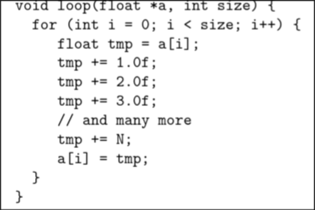

Therefore, I just broke it into 3 parts. The float tmp = a[i] creating that tmpN (depending on the unroll factor), then adding to that for as many times in the chain_length starting from 1, lastly equating that tmpN to the proper a[i+N] val. Then we skip by the unroll factor to continue the process to add to the entirety of the array. Knowing that skeleton allowed me to solve for the sequential loop.

For the interleaving loop, it’s just interleaving the addition process before adding them together. This just required switching my logic from instead of sequentially adding and then loading that value into the proper array, we will perform all the additions in interleaving fashion and then load all together. This just required adding another loop to the start to first load all the tmpN values, then we will just add the values with all tmp values increasing to the 1, chain_length+1 times, then finally summing it all together. The C++ code I was aiming for was:
for (int i = 0; i < size; i += 2) {
float tmp0 = b[i + 0];
float tmp1 = b[i + 1];
tmp0 += 1.0f;
tmp1 += 1.0f;
tmp0 += 2.0f;
tmp1 += 2.0f;
tmp0 += 3.0f;
tmp1 += 3.0f;
tmp0 += 4.0f;
tmp1 += 4.0f;
b[i + 0] = tmp0;
b[i + 1] = tmp1;
}
Where this was an unroll_factor of 2 and chain_length of 4, therefore I just had to create the proper python script to reflect this.

Unrolling Reduction Loops for ILP (31 points)
My thought process for part 2 was using what I did in part 1 in terms of logic, however we just have to do the unroll factor and are adding the values from a[i+N] to the tmpN values and then finally adding them all up at the bottom. So for this function, it’s similar to the C++ of the interleaving loop. Therefore, I just need to firstly, instantiate the tmp vars. Secondly, use a for loop to add to each var from sumN += a[i+N] where i is skipping by the unroll_factor and is going from 0 to the size. Lastly, sum it all up. Knowing how to use python loops to create that repeating C++ variables made this part go much quicker. Overall, I just reused most of the interleaving code and added the total summation at the end and adding the array to the tmp variables.

SPMD Parallel Programming Using C++ Threads (33 points)
Part 3 required three different algorithms but thankfully we could write directly into C++.

The sequential_increment function required a brute force solution where it just utilizes the parameters of the size, and incrementing in a for loop from 0 to size and then having a while loop inside to ensure it does enough additions until it is equal to k.

The round_robin_increment was building off the sequential increment in which we include a parameter of num_threads and then we will only allow the proper thread id to compute the array that followed the restriction i % NUM_THREADS = tid. Thread ID being the sequential ordering of the generated threads. Therefore, I knew we had to use multiple threads so I will require an array of threads (for simplicity). Then, we will generate worker threads that will operate a worker_round_robin_increment (will elaborate on what this function does), then will join to conclude the operation. The worker_round_robin_increment passes along all inputs but also the value of i from the for loop which corresponds to the tid. From this, we create a whole new function called worker_round_robin_increment which is just the sequential_increment_function, however i = tid and it will increment by i+=num_threads.

The custom_increment was a bit harder since I attempted multiple different approaches in which my first approach was to just change the round_robin_increment to instead compute sequentially but that led to many data race conditions and actually lowered optimization. Then I attempted a level of blocking in which the threads don’t need to write over eachother in which I would divide the total size of the array into “blocks” that the threads could run on, giving me a block = size/num_threads, start = tid*block, then the last thread would be either to the end of the array (size) or till the end of its’ respective block. This uses the same main of the round_robin_increment but just changed the worker functions.

